Site Content for Sy Soccer

What we need from you to get your site live. Preview your site: <http://sysoccer.trwebdev.com/>

# Home Page

## Landing page header

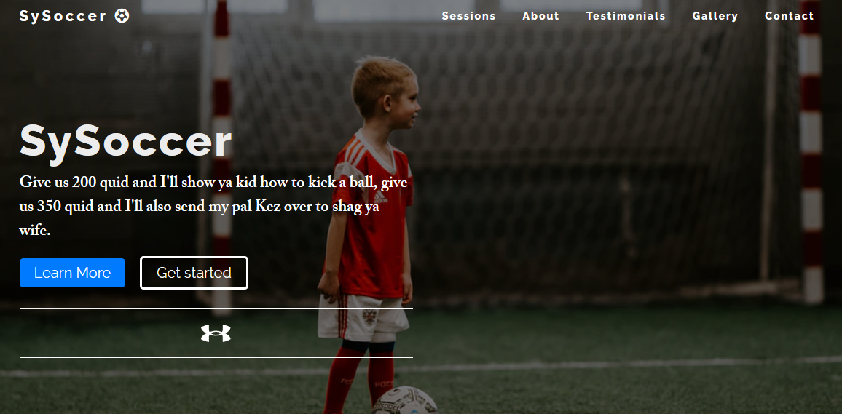

1. Background Image
2. Title
3. Intro Text (optional)

## Intro Section

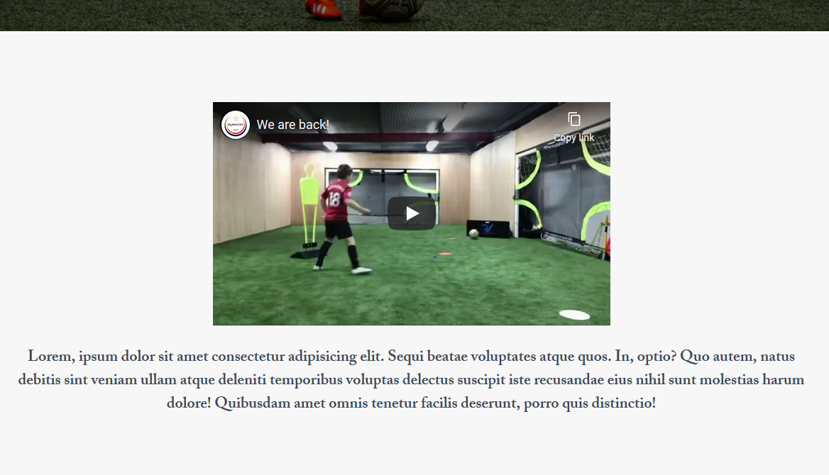

1. Video URL
2. Short intro about what Sy Soccer does (about 45words)

# About Page

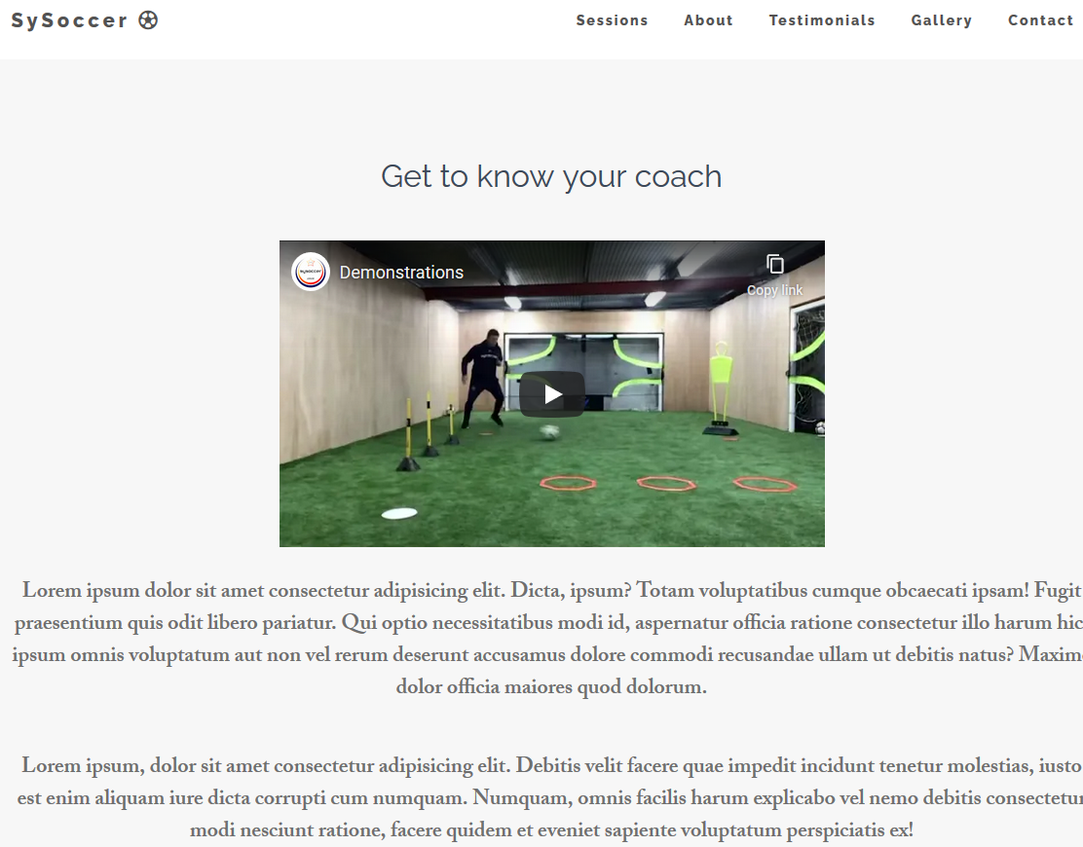

1. Page Title
2. Video URL (Optional)
3. A couple of paragraphs to explain your services.

# Testimonials

Send us any of your testimonials.

# FAQ Page

If there are any common questions you get from clients or potential clients that you want everyone to know about, this is the perfect place to answer them.

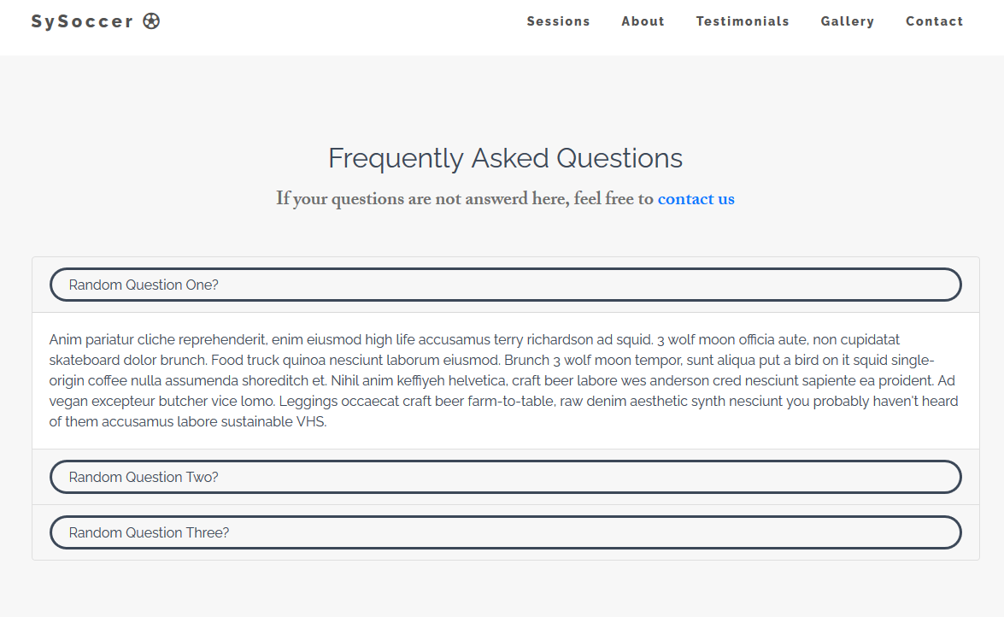

# Sessions

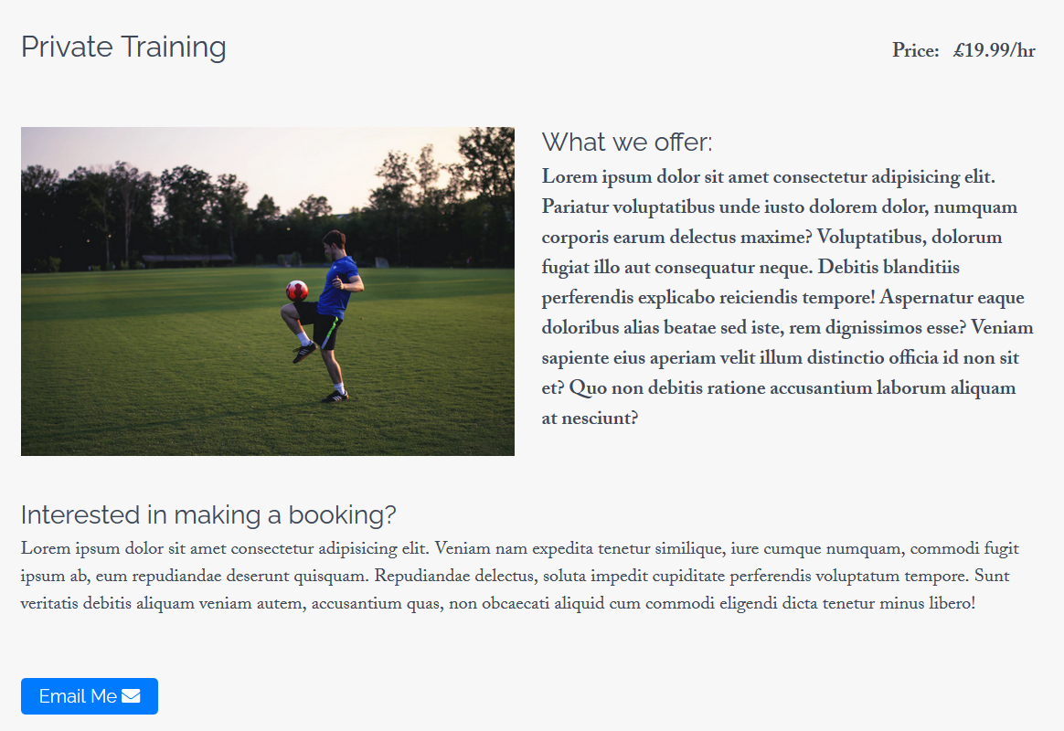

1. Session Names
2. Prices you charge for each session.
3. An Image to display for each session.
4. Some general information about each session.
5. Information on how to book a session.

# Contact

1. Your email address
2. Your Social Media Links